Yifan Yang 40038814 2019/09/12

Page 11

Question 10

Regardless of shelf, it is a permutation problem, there are 15P15 ways to place them with a special sequence

Then there are 14 ways to put a divider in the sequence

14\*(15P15)=14\*15!= 1.8307441e+13

(The question is not very clear, are the shelves same? For example, 123|4 can swap to 4|123 if the shelf are the same, then the answer should be 14\*15P15/2 )

Question 38

Place women firstly

9!/9=8! (cause the table is circle)

Then at every women right hand side, there will be a free seat for 6 man to seat

So it is 9P6 (sequence matters), ways for man sequence

8!\*(9P6)=8!\*60480= 2438553600

Page 24

Question 8

(a)5 number from 13 (sequence doesn’t matter)

(13C5)\*4= 1287\*4= 5148

(b)4 aces and 1 random

4C4\*48=48

(c)13 kind \* 1 from rest

13C1\*48=624

(d)3 aces from 4 and 2jacks from 4

4C3\*4C2=24

(e)3 aces from 4 \* a pair from 12(cause there are no enough ace) \* 2 from a pair   
4C3\*12\*4C2=228

(f)3 from a kind \* a pair from 12 \* 13kinds \*2 from a kind

228\*13=3744

(g)this question is not clear

The rest 2 can be 1 kind: 3 from a kind \* 2 from other 48 =4C3\*13\* 48C2=58656

The rest 2 cannot be 1 kind: 3 from a kind \*1 from other 48 \*1 from other 44 /2 (the rest 2 has a sequence order) =4C3\*13\*48C1\*44C1/2=54912

(h)2 from 4 \* a suit from 13 \* 2 from 4 \* a suit from rest 12 /2(pair choose has a sequence order)\*the rest 1 from 44

4C2\*13\*4C2\*12/2\*44=123552

Question 18

1. It is different kinds of identical items permutation so it is 10!/(4!\*3!\*3!) =4200
2. Take eight 1 for example, we need to pick 8 space to put 1 ,then the rest 2 can be012, so

10C8\*3^2+10C9\*3+10C10=436

1. 4=4\*1+6\*0=2\*2+8\*0=2\*1+1\*2+7\*0

10!/(4!\*6!)+10!/(2!8!)+10!/(2!\*1!\*7!)=615

Question 26

1. Pick 2 w 2x 2y 2z 2 ‘1’

10!/(2!\*2!\*2!\*2!\*2!)=113400

1. Pick 2\*‘2w’ 2\*‘-x’ 2\*3y’ 2\*z’ 4\*’-2’

12!/(2!\*2!\*2!\*2!\*4!) \*(4\*1\*9\*1\*2^4)=718502400

1. Wxyz is same as b, and there is no v, so we need 4 ‘3’

12!/(2!\*2!\*2!\*2!\*4!)\*(1\*4\*1\*25\*3^4)=1.010394\*e+10

Question 28

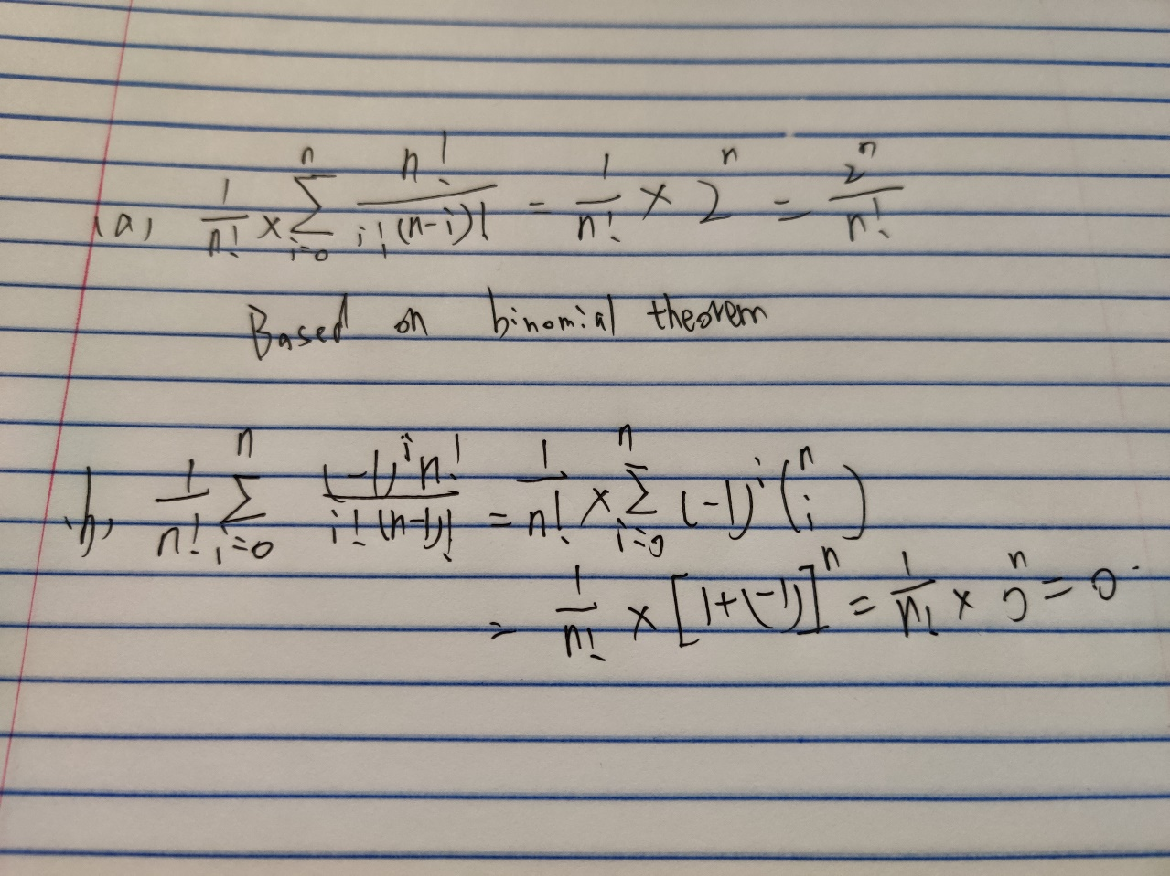

Don’t know how to type sigma so I take a photo

For a, it is just binomial theorem

For b, it is a binomial theorem for (1+(-1)) ^n, then its expansion will be Nc0\*1^n\*-(1)^0+….

+NcN\*1^0\*(-1)^n

Page34

Question 12

1. x1+x2+x3+x4+x5<=39

if we think +1 is item x

then the question will become

xxxx|xxxxx|xxxxx|xxxx|xxxxx|xxxxxxxxxx

x1 x2 x3 x4 x5 the rest

there 39 x to pick, cause it is less or equal than, we need another divider (the last divider) for situation ‘less than’

then the question will become 39 item and 5 divider

44C5=1086008

1. consider yi=xi+3>=0

x1+x2+x3+x4+x5<=39

y1+y2+y3+y4+y5<=54

then the question is similar to (a)

54 item and 5 divider

59C5=5006386

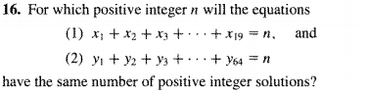

Question 16

this question is same to the XXX|XXX|XXXX|XXXXX stuff in question 12

cause every solution must be positive integer

then we need yk=xk-1

then the question will become

y1+y2+y3+……y19=n-19

y1+y2+y3+….y64=n-64

(n-19+19-1)C(n-19)=(n-64+64-1)C(n-64)

(n-1)C(n-19)=(n-1)C(n-64)

n-19+n-64=n-1 // this step is cause nCk=nC(n-k)

2n-83=n-1

N=82

就没啥可说的，一切都要转到0，因为0才能让divider排到最左or最右

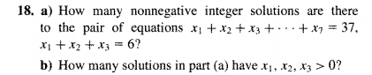

Question 18

(a)//注意下面的数是种类-1,代表着divider

x4+x5+…x7=31

4 kinds with 31 items

(31+4-1)C3=5984

Then we need possible x1x2x3

X1+x2+x3=6

3 kinds with 6 item

(3+6-1)C6=28

5984\*28=167552

(b) yk=xk-1>=0

x1+x2+x3=6

y1+y2+y3=3

3 kind with 3 item

(3+3-1)C2=10

10\*5984=59840

Page219

Question 10

1/when n=2

|x1+x2|<=|x1|+|x2| true

2/assume

|x1+x2+x3+….xk|<=|x1|+|x2|+…|xk|

For all k<=n

3/let y=x1+x2+x3+…xk

|X1+X2+X3…Xk+Xk+1|

=|y+xk+1|<=|y|+|xk+1|<=|x1|+|x2|…+|xk|+|xk+1|

Question 12

1/when n=0

F0=F2-1 true

2/

Assume

F0+F1+F2….+Fk=Fk+2 -1

For all k<=n

3/ F0+F1+…FK+F(K+1)=

F(K+2)-1+F(K+1)=F(K+2)+F(K+1)-1=F(K+3)-1

18.

a/

k=0 321 1

k=1 132 213 231 312 4

k=2 123 1

b/

k=0 4321 1

k=1 1432 2143 2431 3142 3214 3241 3421 4132 4213 4231 4312 11

k=2 1243 1324 1342 1423 2134 2314 2341 2412 3124 3412 4123 11

k=3 1234 1

c/

#ascent+#descent=#number-1

4+#descent=6

#descent=2

d/

m-1-k as/c discussed

e/

1. it means the 9 cannot creat new ascent, while it is the biggest number, it can be put at the (1)head (2)between the previous ascent, then it can replace the original ascent. Eg. from a(ascent)b to a(ascent)9(descent)b

so the answer is 1+4=5 since there are 4 ascent in 12436587

(ii) it can be put at (1) tail (2)between the previous descent, Eg a(descent)b to a(ascent)9(descent)b

So the answer is 1+3=4 since there are 3 descent in 12436587

f/π4,2= (4-2) π3,1 + (2+1) π3,2

π(m,k)=(k-m)π(m-1,k-1)+(m+1)π(m-1,k)

this is just a guess if we think m=4,k=2

then we need to prove it

firstly, we regard m as a constant number

1/when m=4,k=2 true

2/ assume π(m,k)=(k-m)π(m-1,k-1)+(m+1)π(m-1,k)

For all k<=n

3/we should prove π(m,k+1)=(k+1-m)π(m-1,k)+(m+1)π(m-1,k+1) but I don’t know how

Then we regard k as constant number

1/

2/

3/